*PROCESS DOCUMENTATION**1) Introduction* The goal of this project is to design a game that is aimed for the use of all types of audiences. Mechanics and usage of this game system is further discussed in user tutorials. Intented time of creation is three months with no significant budget.*2) Project Organization* The project consists of eight personnel that are assigned to various tasks;  
-Berkay Koçak as manager and general tester.  
-Ahmet Mete Karayaka as the progress observer and the documentor.  
-Adnan Çığtekin as the lead programmer.  
-Afşin Baran Bayezid as the secondary programmer.  
-Uğur Nezir as user interface designer and 3rd programmer.  
-Mehmet Selimoğlu as user interface designer  
-Mehmet Kaan Öztürk as modeller.  
-Murathan Biliktü as modeller.  
 As for software process model, team used an iterative approach. That is as a team, project is divided into smaller parts then designed, developed and tested in repeated cycles until there is a functional software that is ready to be presented to users.  
*3) Risk Analysis* At the beginning of the project, team faced a risk of modellers leaving the project. Lead modeller was informed about this risk and if there exists a situation like this, team agreed on purchasing some models for the good of the project.  
 At beta 1 process of the project, team faced a risk of new modellers joining into the project. To prevent deceleration of the project models have been constantly updated so that new modeller could see at what stage the project was. In case a new modeller joined to the project, the team agreed to plan an informative meeting for the new modeller.  
 At the beginning of the project, team faced an IOS implementation risk. Since team had no experience with the IOS, IOS version of the project is postponed.  
*4) Hardware & Software Resource Requirements* In terms of hardware, the team needed no hardware. In terms of software, the team needed Unity software that the project was going to be developed on.  
*5) Project Schedule* Gantt chart of the project is shown below;

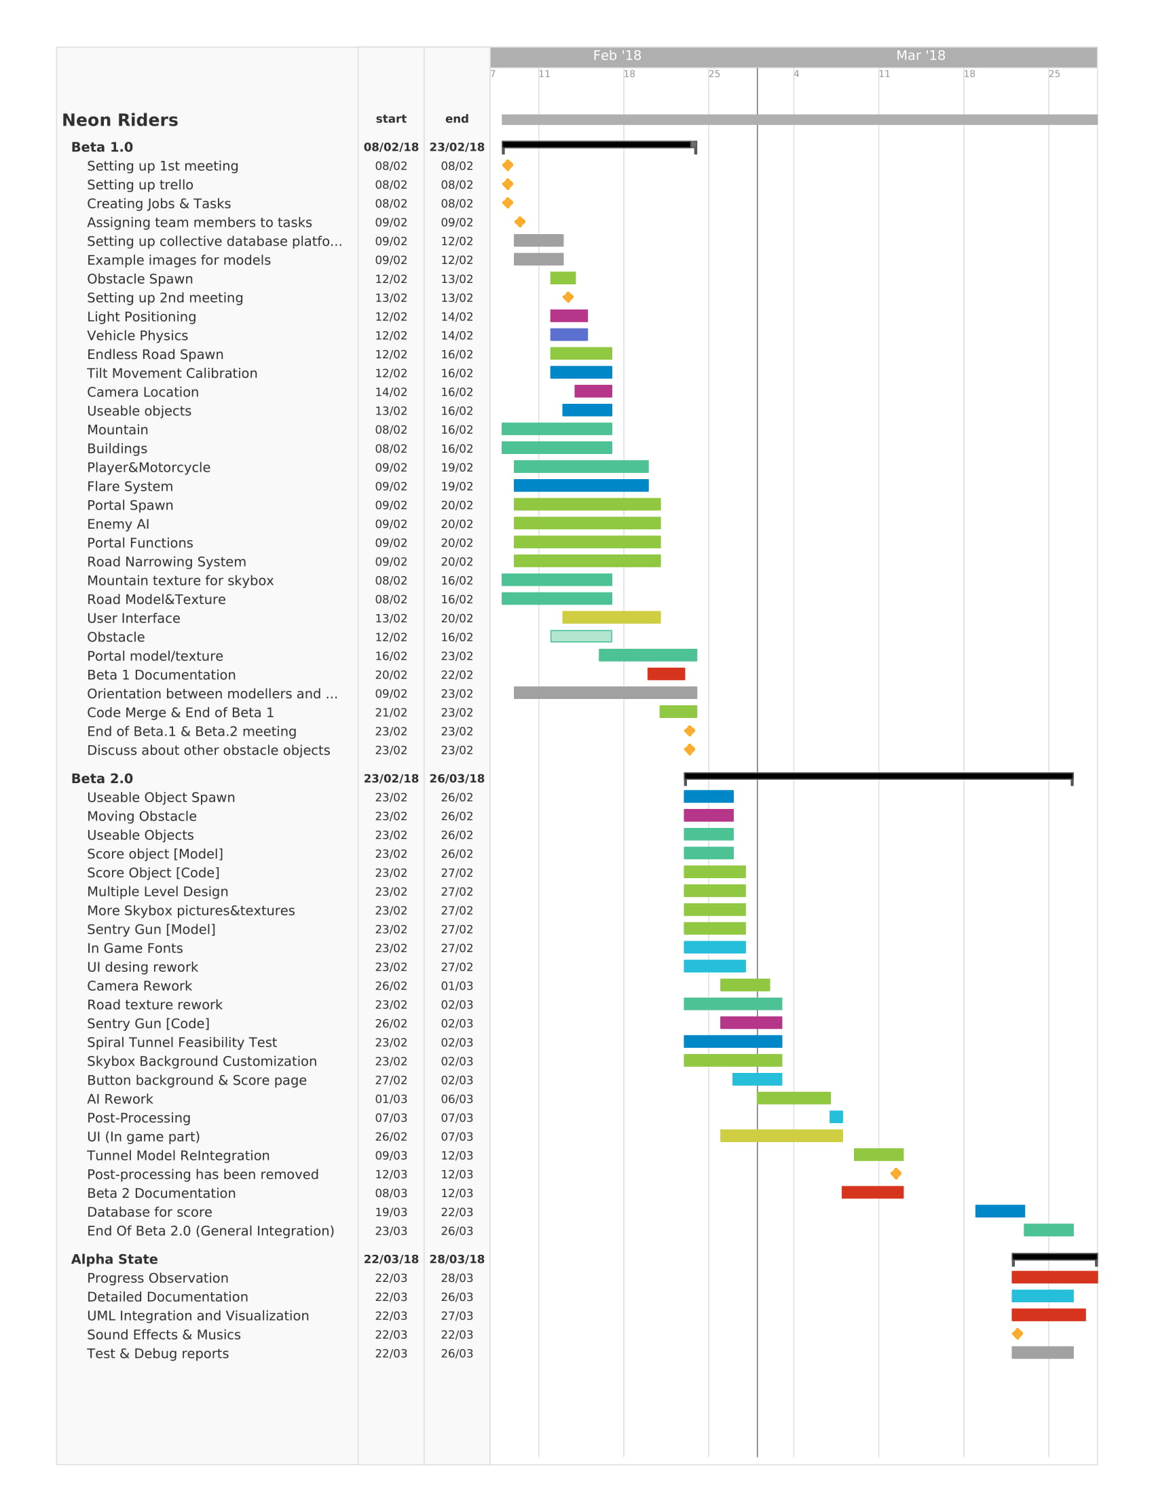

*6) Used Software* Team used Unity and Microsoft Visual Studio as external software.*7) Work Breakdown* Processes, milestones and their time of creations of the project are defined as; ***Beta 1 Process: Time Table and Milestones***

***Group Communication;***8th of February;  
 **1. First meeting is set up. Game structures, characteristics and features has been hashed out.  
 2. Observable tasks and jobs has been noted.  
 3. For planned operation, a Trello page has been created.**9th of February;  
 **1. Team members has been assigned to various tasks.  
 2. A collective database has been set up for team members’ shared usage.**  
13th of February;  
 **1. Second meeting has been established to further discuss the game mechanics.**23rd of February;  
 **1. End of the beta 1 process meeting has been established. Implementation of new mechanisms and new objects about the game have been discussed.**  
  
***Modelling Process;***  
10th of February;  
 **1. Example assets has been uploaded to Trello for better design.**  
12th of February;  
 **1. Road model has been created, received and uploaded to database.**  
16th of February;  
 **1. Initial User Interface design has been created, received and uploaded to database.  
 2. Boost Icons has been created, received and uploaded to database.  
 3. Building design has been created, received and uploaded to database.**23rd of February;  
 **1. Portal model and texture has been created, received and uploaded to database.**

***Gameplay Mechanics;***14th of February;  
 **1. Movement system for player model and AI model has been created.**  
 *- Speed and accelaration systems have been created depending on the player’s tilt density.  
 - Collision detection on walls has been added.  
 - Spark and explosion effects on collision have been created, their threshold has been defined.  
 - Rotation system has been added, depending on the density of tilt.*  
16th of February;  
 **1. Tilt movement calibration mechanism has been added.**  
 *- Maximum values and minimum values of acceleration and speed has been defined according  
to the tilt mechanism. Relation between acceleration and speed has been defined depending on the tilt mechanism.*  
 **2. Dynamic camera system has been added.**  
 *- Depending on the tilt and the existence of an AI controlled asset, camera location is designed to be change.*  
 **3. Mechanism that provides allows users to receive boost in-game has been designed.**  
 *- Boost collision detection has been implemented.  
 - Boost increase and decrease mechanisms has been implemented depending on user’s usage of boosts.*  
20th of February;  
 **1. Enemy AI has been implemented.**   
 *- AI’s assets movements, that are passing the player and blocking the player has been  
implemented. This movement starts slow and increases over time to the level that player will be left behind of AI asset. Camera movement has been polished for clear observation of the AI asset.*21st of February; **1. Flare System has been implemented.**  
 *- A flare mechanism that damages the player once player collides with flare has been implemented. Flare follows AI asset’s path throughout the asset’s time of existence.*23rd of February;  
 **1. Different pieces of codes have been merged to get an early representation of the game and Beta 1 process has been concluded.**

***Environment Process;***13th of February;  
 **1. Obstacle spawn mechanism has been created.**  
 *- Obstacle spawn mechanism has been arranged so that obstacles are going to spawn randomly   
in an interval of decided frequency. Locations that obstacles spawn are randomly generated.*  
14th of February;  
 **1. Light positioning system has been created.**  
 *- Depending on the models’ location and their movement, lightning is dynamically created and updated. These models include environment, player and road.*  
16th of February;  
 **1. Road spawn mechanism has been added.**  
 *- Depending on the current stage of the game, change of road type has been implemented.  
 - Endless road spawn mechanism has been implemented.*  
20th of February;  
 **1. Road narrowing system has been created.**  
 *- Depending on the stage of the game and the existence of an AI asset, road narrowing system is implemented to take place.*  
 **2. Portal System has been created.**  
 *- Player’s displacement of the road through the portals has been implemented. Players are teleported to the opposite side of the road when they go into a portal.*  
 **3. Portal spawn system has been implemented.**  
 *- Depending on the existence of an AI asset and the size of the road, portal system is implemented to spawn.*20th of February;  
 **1. User interface has been created.** *- Menu page and its buttons, game over page and its buttons, credits page and its buttons have been implemented.*

***Beta 2 Process: Time Table and Milestones***

***Modelling Process;***  
25th of February;  
 **1. Score object design has been created, received and uploaded to database.  
 2. Nitro object design has been created, received and uploaded to database.  
 3. Flare object design has been created, received and uploaded to database.**27th of February;  
 **1. To be used in different levels in the game, different skybox and background textures/pictures have been created, received and uploaded to database.  
 2. Sentry gun asset has been created, received and uploaded to database.  
 3. User interface design has been created, received and uploaded to database.  
 4. In game fonts have been created, received and uploaded to database.**2nd of March;  
 **1. Road texture has been reworked.**3rd of March;  
 **1. Button background and score page desings have been created, received and uploaded to database.**

***Gameplay Mechanics;***25th of February;  
 **1. Spawn system of the objects that can be interacted has been implemented.**  *- Score object spawn mechanism has been created.  
 - Collision detection of the enemy asset’s flare has been further improved.   
 - Nitro object spawn mechanism has been created.*27th of February;  
 **1. Collision detection of the objects that can be interacted has been implemented.**  *- Collision detection of score object has been implemented, a counter for score has been added.  
 - Collision detection of nitro object has been implemented, a counter for total amount of nitro has been added.*2nd of March;  
 **1. Camera has been reworked.**  *- In order to be more precise about the location of obstacles and enemy asset, camera has been reworked to be closer to the player.* **2. Sentry gun has been added.**  *- A sentry gun that is set to follow the user has been implemented. Sentry gun range has been defined, sentry gun is designed to shoot two projectiles at user. Path amd the speed of sentry gun’s projectiles has been implemented.* **3. Spiral tunnel mechanism’s feasibility has been checked.**  *- Spiral tunnel has been found to be doable and decided to be implemented in game. Spiral tunnel system is going to provide user with more escape routines from the enemy asset.*4th of March;  
 **1. Enemy AI has been reworked.**  *- Enemy asset’s AI has been reworked to give player a hard time inside the tunnel. Enemy asset’s movement has been smoothened.****Environment Process;***25th of February; **1. Moving obstacle has been created.**  *- A moving obstacle has been created to give some flow and dynamism to the game. Moving object shares the same spawn mechanism as constant obstacles. Moving obstacle’s speed and movement system has been implemented.*27th of February;  
 **1. Multiple level design has been created.**  *- Depending on the score of the player and the stage of the game, visual looks of background and skybox are designed to change.*2nd of March;  
 **1. Multiple level design reworked.**  *- Rather than using score and the stage of the game as a treshold for change, the existence of a tunnel is set to be the threshold of the level change.*4th of March;  
 **1. In game user interface has been implemented.**  *- Received user interface models have been merged with the game.*11th of March;  
 **1. Post processing has been added.**  *- Some aspects of post processing has been added, post processing has been designed to not to cause performance issues.*21st of March; **1. A database for user scores has been created.**  *- A local database for user high scores has been created. The database hold the top ten high scores of the user.*

***Alpha Process: Time Table and Milestones  
  
Gameplay Mechanics;***23rd of March;  
 **1. All source code, models and UI designs have been integrated to form the final product.  
 *Environment Process;***25th of March; **1. Post processing cancelled due to performance issues.  
 2. Slight colour tweaks have been done to models to further visually enhance the game.  
  
*Documentation;***25th of March; **1. Documentation of the project is completed.**  *-Process, user and system documentation has been created. A tutorial for user has been created. A detailed timechart for progress observation has been created.* **2. Test & Debug reports has been created.**

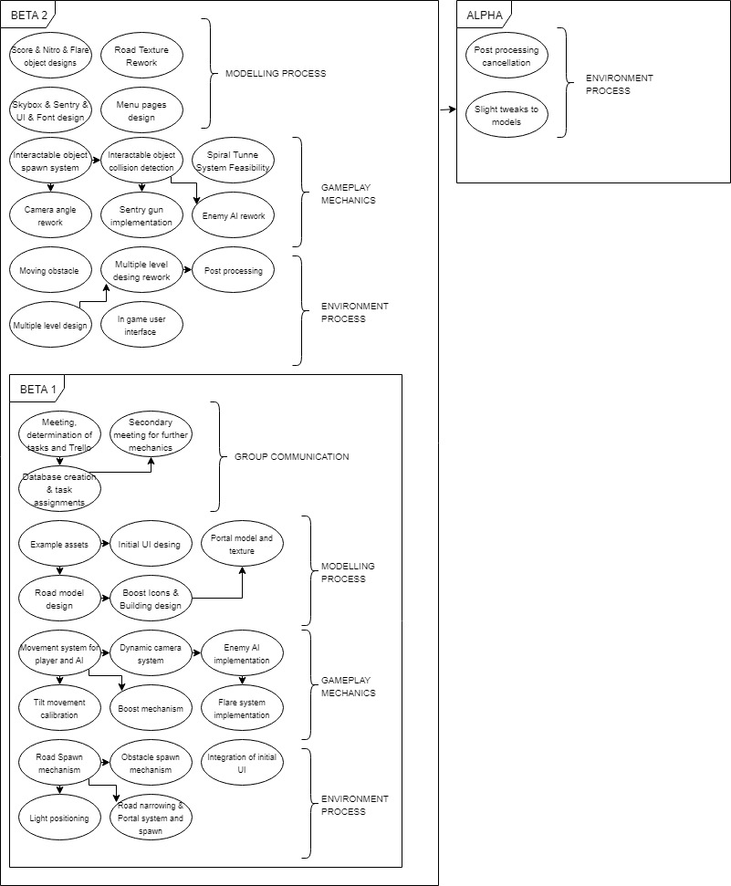

*USER DOCUMENTATION  
1) Introduction* As mentioned in the process documentation the goal of this project is to create a time-killer game for all types of audiences. In this project there is one type of user, that is the player.  
*2) User Tutorial* Currently, the users can only reach the project via downloading the .apk file and supported systems are Android and PC.  
***Main Menu***  
 When the project is run, user is greeted with a main menu. In this menu user can play the game by pressing the “PLAY” button, user can see the people involved with the project and their tasks by pressing the “CREDITS” button and user can see their top ten higest scores by pressing the “SCORE” button.  
***Gameplay Screen*** When the “PLAY” button is pressed, user is taken to the game. The purpose of this game is to get the highest score without dying. Game lasts until player dies and when the player dies their score is saved. *A simple guide for the flow of the game:*  
***In the game there are two terrains;***  
***Highway***: This is the terrain that most of the game takes place. This terrain is quite large. Coins, nitro bars, flare bars, enemy bike, sentry turrets and neutral bikes spawn in this terrain. User will be notified by camera movement when the enemy bike spawns.  
***Tunnel***: This is the terrain that user proceeds when the enemy bike passes the user in highway. The road narrows almost to the half which makes this terrain quite dangerous. At the entry of the tunnel there lies two portals which teleport user to the end of the tunnel. Enemy AI manoeuvers in front of the user in the tunnel so if user lacks a nitro and missed the portal at the entry of the tunnel user is killed in the tunnel.  
 ***In the game, there are some interactable objects;***  
***Coins***: Instantly adds 500 points to user’s current points.  
***Nitro Bar***: Defines the nitro for the player.  
***Flare Bar***: Defines the flare for the player.  
***Enemy Bike***: An AI bike that tries the kill the player using its flare.  
***Sentry Turret***: A weaponized automaton that tries to shoot and kille the player.  
***Neutral Bike***: An innocent AI that travels the road, when user collides with the neutral bike, player dies.  
***Portal***: Teleports the player to the end of the tunnel.   
 ***In the game, there are two mechanics;***  
***Nitro***: Increases the speed of the player drastically allowing the player to pass the enemy bike.  
***Flare Bar***: Puts a trail of flare behind the player which can be used to kill the enemy bike.  
 ***Simply an use case diagram for the project would be;***

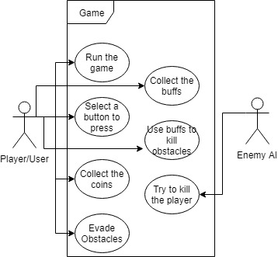

*SYSTEM DOCUMENTATION****//SOURCE CODES GO HERE***